LRFB Public Meeting Minutes
February 16, 2023 at 4:30 pm

Lockett Ranches Fire District Board Meetings are public and held virtually via the Go To Meeting online meeting platform. Members of the public wishing to attend these meetings can do so using the following meeting credentials: https://meet.goto.com/525579565
You can also dial in using your phone: United States: +1 (646) 749-3122 Access Code: 525-579-565.
- Member Roll Call / Establish Quorum/ Call Meeting to Order
Meeting was called to order at 4:35 pm.
In Attendance: P A
John Noll X
Jim Schmelzle X
Phil Hagen X
Steve Vargas X
David Weeks X

- Call to Public
None Present

- Review Meeting Minutes
Review and approve the regular meeting minutes of January 19, 2022.

No corrections were offered. Jim made a motion to approve with a second from Phil. Minutes were approved unanimously.

- Old Business
Next Fire District email to owners planned for March/April:
    - Firewise recognition articles –
      - Subera Lane and Chaser Trail pavement projects
      - Recent lot treatment projects
Emergency Equipment Access survey results (to be sent by Adam Whitman to all owners).

The way forward with recognition articles and the Access survey was discussed. Phil noted that no response on before-and-after photos has been received from Allstate regarding Jack Howley’s required treatment. John mentioned that Allstate had called to say they didn’t have any suitable photos. Jim agreed to contact owners (Bell & Kaufmmann, Spravzoff & Grasser, Howley) to ask if they had any photos or if a board member could drop by in the spring to take a few.
A request for the Equipment Access Survey to be sent out by Adam Whitman will made in the spring, once the weather warms up and people’s attention turn to activities other than shoveling snow.

- New Business
Review and approval of FY 2022 Financial Report from Stephens & Co.

No report has been received from Stephens & Co. so the Financial Report could not be reviewed and approved. They have promised the report next week and it is due to the Treasurer’s office on Friday February 24. It was decided that when it is received, John will send the report to board members via email for review and the Board will hold a special meeting to approve it next week – probably on Wednesday. John will schedule that special meeting and post it to the website and Jim will take the agenda to the Community Development office for posting. John will forward the agenda via email to Sterling Management for posting at their office.

Discussion: Fire District CC financial reports for January 2023.

The Fund Balance Summary report for January 2023 was reviewed. It was noted the District has accrued enough funds from property tax receipts and FDAT to pay the next invoice for fire & EM protection from the City of Flagstaff that will be due in mid-May.

Discussion: Possible impacts of recent increases in Fire District AV on future district tax rates.
For the benefit of our new Board members, John reviewed the origin and status of the contract for Fire Protection with the City of Flagstaff. The details of the contract are shown in the table below. It was noted that limited property values (LPV) for individual homes have been increasing at the state mandated 5% level but that Full-Cash Values (FCV) have increased over 82% during the last two years! It was noted that the negotiated changes to the contract that required use of LPV instead of FCV and the change to limit the yearly contract increase to 2% per year instead of using the CPI has saved owners a considerable amount of money.

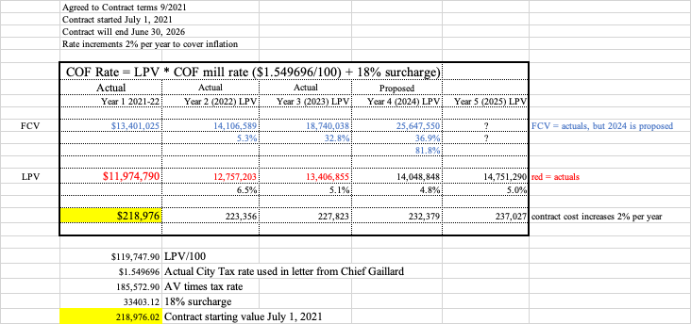

- Open Forum
Jim asked about the resolution regarding the Lockett Estates (LE) fire hydrants. John explained that the City of Flagstaff Fire Department (FFD) and the Board of Directors for LE were both contacted about the status of the hydrants. The FFD has offered to assist LE in evaluating the hydrants and help oversee any repairs needed. Because LE owns the equipment, they will have to be responsible for these repairs.

- Adjournment
Phil made a motion to adjourn, with a second from Jim. The meeting was adjourned at 5:11 pm.
Minutes prepared by John Noll

- Next Meeting The next meeting will be March 15, 2023 via Go To Meeting.

