LRFB Public Meeting Minutes
May 16, 2024 at 4:30 pm

Lockett Ranches Fire District Board Meetings are public and held virtually via the Go
To Meeting online meeting platform. Members of the public wishing to attend these meetings can do so using the following meeting credentials: https://meet.goto.com/525579565
You can also dial in using your phone: United States: +1 (646) 749-3122 Access Code:
525-579-565.

- Member Roll Call / Establish Quorum/ Call Meeting to Order
Minutes to be prepared by the John Noll, Board Chairperson

Meeting called to order at 4:41 pm.

Fire Board Members:
P A
X John Noll - Chairperson
X Jim Schmelzle – member
A David Weeks – clerk
A Steve Vargas – member
X Lottie Herkenhoff

- Call to Public
None present

- Review Meeting Minutes
Review and approve the regular meeting minutes of April 18, 2024.

Minutes were reviewed. John Noll suggested an addition to clarify what was resolved regarding what the Board would do before Spring Cleanup. This mistly related to sending out a Fire District newsletter. That addition was accepted; Jim moved to approved the minutes as amended, Lottie seconded, all approved.

- Old Business.
- Discuss progress to create a system to track and report on Lot Reviews and Forest Treatments that are planned and completed.

A discussion occurred around how to create the tracking system. John shared how the Coconino County Parcel Viewer could be used to identify lots where reviews or treatments were completed, once the address is known. Lottie suggested creating a spreadsheet to use along with the Fire District map to track progress and would start this by contacting Mark Adams to get an update on who had requested lot reviews and which ones had been recently done.

- Progress scheduling Lot Review meetings for Board members?

John Noll has requested a lot review and other board members presents resolved to do the same soon.

- Fire District Financial update: review of latest County report; May Fire Protection contract warrant paid on May 8; Business Signature Card for Lottie Herkenhoff processed;

John shared the April financial report for the District which showed $122,229.78 cash on hand. The May 8 Fire Protection invoice was $113,911.32 leaving only $8318 left in the account. Only minor expenses remain to be dispersed in FY2024, but this amount was judged by the Board to be too little for possible expense contingencies. The amount of reserve will need to be increased in FY2025 and that budget process will start next month.

- Spring Cleanup in progress

No issues have been reported. John reported owners are cleaning up the site after filling bins and hopefully that will continue.

- Owner feedback on April newsletter
Positive comments were received from 2 owners about the newsletter:
“Great newsletter from LROA Fire District. That satellite image was really good to share with all of us. -I can see we still have work to do even after taking out more than 100 trees…”

“We had Noah from the Flagstaff Fire Dept. out today to do a FireWise inspection. He found a few trees he suggested we trim up but was very pleased with the property. He said he’d love to see more properties like this one. I’ll have Aaron at A&A take care of the few things Noah and I talked about but we won’t be needing any of the grant money. Better for someone else. Ron Kreig, our neighbor, is also going to call for an inspection after reading your newsletter.”

- New Business
- Report on MEE meeting on April 27:
  - Fire Season Outlook for 2024
The Fire Season Outlook is shared below.
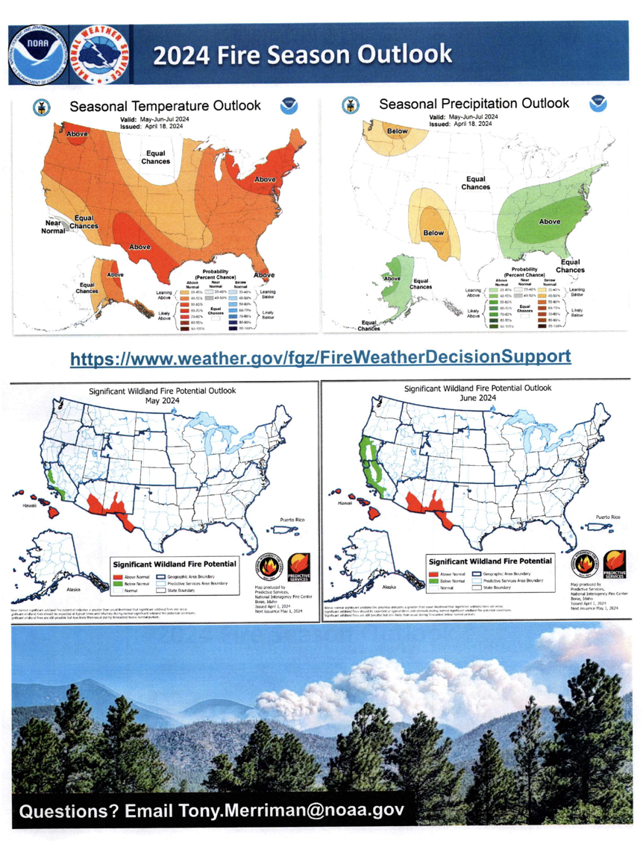

  - Request from NWS for volunteer severe weather spotters
The request from the NWS for severe weather spotters is on the second page of the Fire Season Outlook
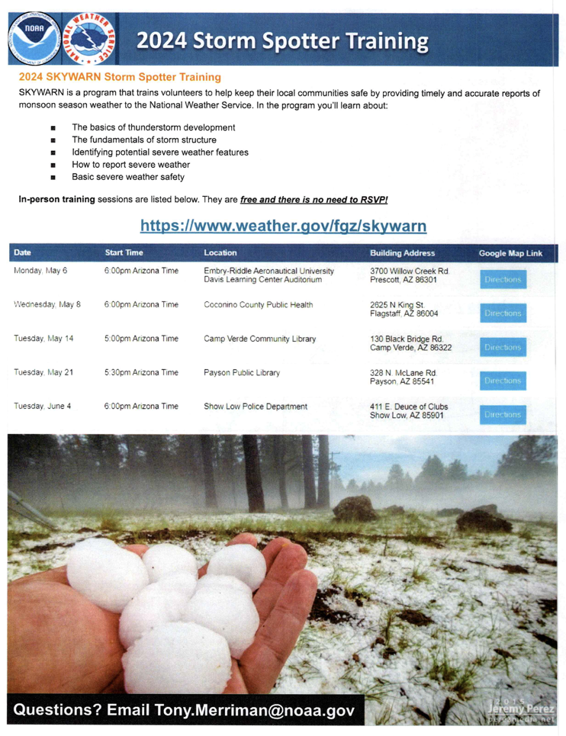

  - Insurance premium increases being experience by MEE residents;
In some case homeowners insurance increases have been extreme (in one case from $4.5K to $14K/year !). We expect these types of increases will become more prevalent in the future unless owners take action to reduce wildfire risk in our area.

  - Emergency egress concerns for MEE residents and request for access to Ryan’s Trail
A request has been made by John Harper (President of Mt Elden Estates HOA) to consider a gate that allows in emergency situations people from Mt Elden Estates to escape their area along N Mule Crossing via N Ryans Trail. The Board was supportive exploring this idea, so John Noll will contact owners along Ryans Trail to see if they are supportive. If so, a recommendation would be made to the LR OA to pursue this on behalf of Lockett Ranches.
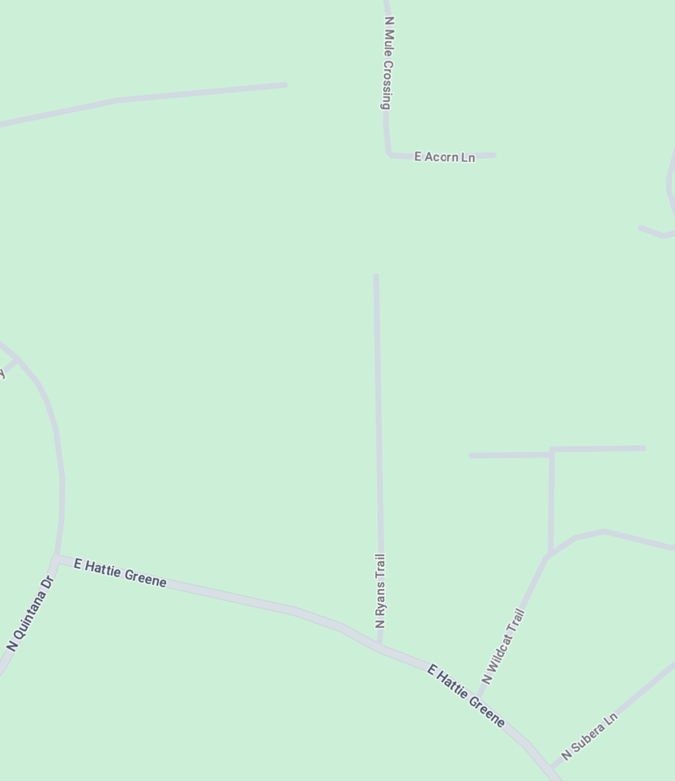
- Open Forum
An advertisement from AZ Wildfire Mitigation was shared and discussed (see below). This flier has been appearing in LR mailboxes. Mark Adams knows one of the principals (Cole Sennett) when they worked together at Flagstaff Hotshots. They offer property inspections and forest treatments. There is the potential for confusion as they are not part of the free LR Lot Review process and couldn’t provide owners with access to grant support as does Mark Adams through the City of Flagstaff Fre Department. It was decided John will write a short newsletter item clarifying that Lot reviews should go through the LR process and that AZ Wildfire Mitigation could be a contractor for any treatment work done after grant support is applied for.

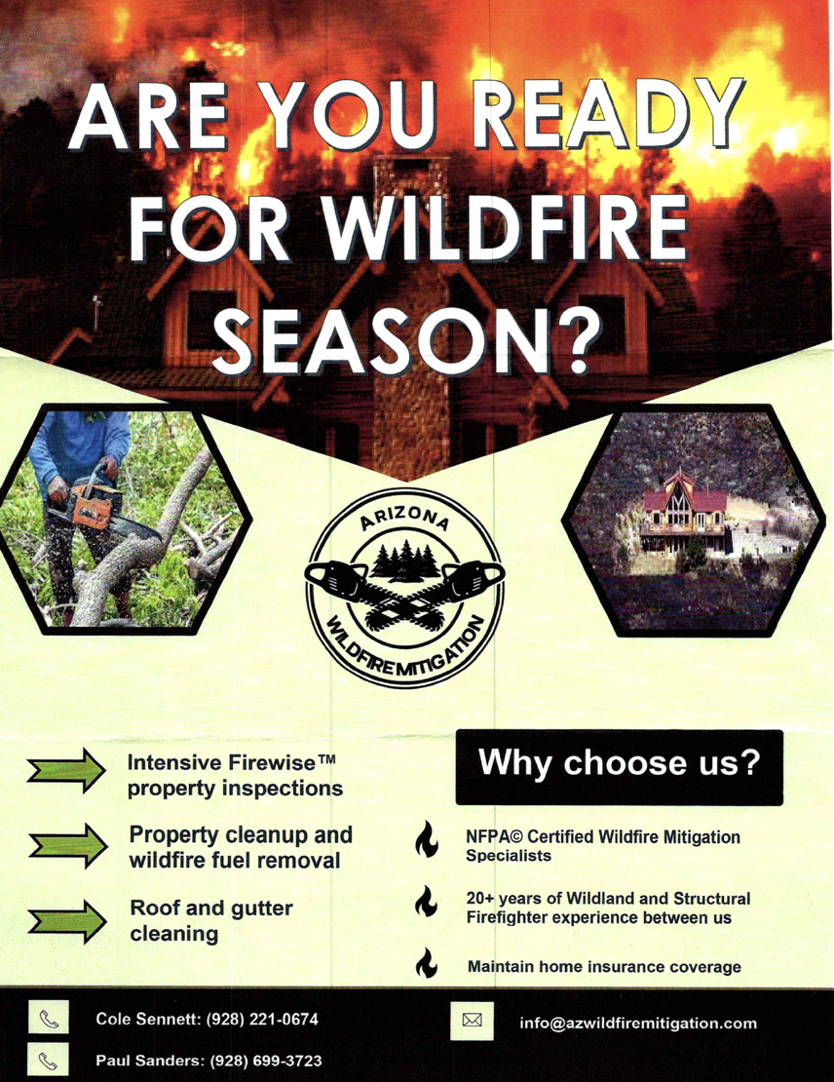

- Adjournment
Jim moved to adjourn, Lottie seconded, the meeting ended at 5:33 pm

- Next Meeting The next meeting will be June 20, 2024 via Go To Meeting. Main topic will be the FY2025 Fire District Budget.

